QUANTITY | MEASURE | INGREDIENTS / DISTRIBUTOR INFO
1 | Each | Sweet Street Salted Caramel Cookie
1/8 | Lb. | Barilla Linguine or similar long cut pasta
1 | Cp. | FAV R PAC Roasted Fiji Apples
1 | Tbs | Libby Pumpkin Puree
½ | Cp | Coffee Mate Vanilla Creamer
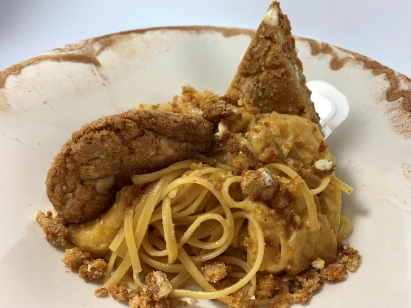
Recipe Yield: 1 serving but serves 2
Prep Time: 15 minutes
Total Time: 20 minutes
cut the cookie into a triangle, which would leave 3 small half moon shapes, save 1 half moon shape, the triangle and crumble the rest. in a saute pan, place the apples, creamer and pumpkin and bring to temp. cook the pasta per instructions, toss pasta into apple pumpkin cream sauce and add a touch of the pasta water, saute until the pasta is well coated and silky, plate, sprinkle with the salted caramel cookie crumbs and garnish with the cut portions of the cookie. serves 2.

NOTE: USE YOUR PROFESSIONAL JUDGEMENT WHEN RESIZING, SEASONING, OR USING DIFFERENT EQUIPMENT. ADJUSTMENTS MAY BE NEEDED

Chef Anthony Marolla, Director of Culinary
CORE Foodservice
AMarolla@COREFoodservice.com
561.889.6849
recipe
Salted Caramel Apple Pasta with Pumpkin cream sauce
directions

