QUANTITY | MEASURE | INGREDIENTS / DISTRIBUTOR INFO
1 | SLICE | NEW YORK CHEESECAKE, SWEET STREET PC 0021
 | GARNISH | MORELLO CHERRIES, SENECA
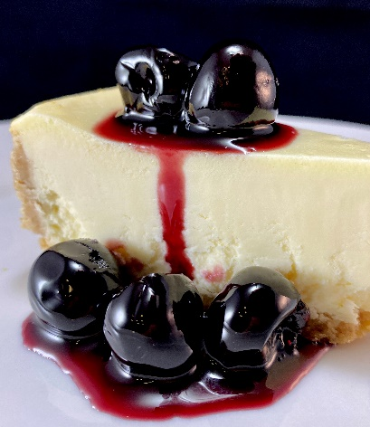

NOTE: USE YOUR PROFESSIONAL JUDGEMENT WHEN RESIZING, SEASONING, OR USING DIFFERENT EQUIPMENT. ADJUSTMENTS MAY BE NEEDED

chef tips:

SUBMITTED BY: MARK STUSSI CEC
MSTUSSI@COREGROUPSALES.COM
626-483-6964
DATE: 9/3/21
recipe
DARK MORELLO CHERRY CHEESECAKE
directions
Recipe Yield: 1
Prep Time: 1 min
Total Time: 1 min
- PLATE AS SHOWN

