QUANTITY | MEASURE | INGREDIENTS / DISTRIBUTOR INFO
1 | EACH | ORIGINAL CHEESECAKE XANGOS PC 7944
 | GARNISH | FALL CHUTNEY, SEE SEPARATE RECIPE
1 | CUP | CHOCOLATE SAUCES, SIMPLY 5, HERSHEY
1 | TEASPOON | SOY SAUCE, KIKKOMAN
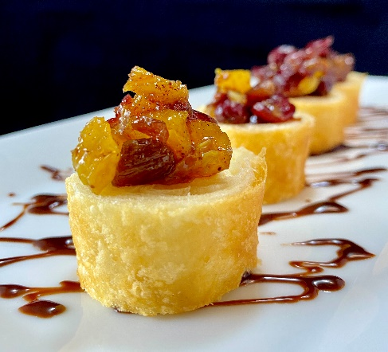

NOTE: USE YOUR PROFESSIONAL JUDGEMENT WHEN RESIZING, SEASONING, OR USING DIFFERENT EQUIPMENT. ADJUSTMENTS MAY BE NEEDED

chef tips:

SUBMITTED BY: MARK STUSSI CEC
MSTUSSI@COREGROUPSALES.COM
626-483-6964
DATE: 9/3/21
recipe
cHEESECAKE SUSHI WITH SOY CHOCOLATE GLAZE
directions
Recipe Yield: 1
Prep Time: 20 min
Total Time: 21 min
- FRY XANGO PER MANUFACTURE DIRECTIONS, COOL A BIT AND CUT INTO DISKS
- TOP SUSHI WITH FALL CHUTNEY
- PLATE AS SHOWN

