QUANTITY | MEASURE | INGREDIENTS / DISTRIBUTOR INFO
1 | SLICE | FOUR HIGH CARROT CAKE, SWEET STREET PC 1120
1 | CUP | VANILLA BEAN YOGURT, DANONE
1 | TEASPOON | PUMPKIN SPICE
1 | TEASPOON | CINNAMON
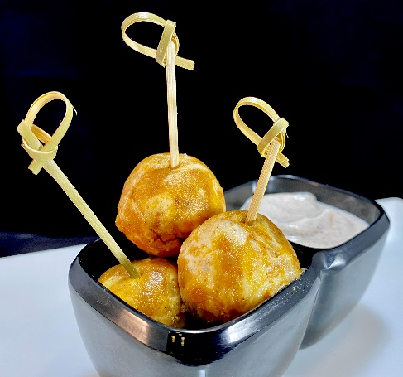

NOTE: USE YOUR PROFESSIONAL JUDGEMENT WHEN RESIZING, SEASONING, OR USING DIFFERENT EQUIPMENT. ADJUSTMENTS MAY BE NEEDED

chef tips: GREAT WAY TO USE BROKEN OR DAMAGED CAKE SLICES

SUBMITTED BY: MARK STUSSI CEC
MSTUSSI@COREGROUPSALES.COM
626-483-6964
DATE: 9/3/21
recipe
CARROT CAKE TRUFFLES WITH SPICED YOGURT SAUCE
directions
Recipe Yield: 6 TRUFFLES
Prep Time: 5 min
Total Time: 6 min
- MASH CARROT CAKE WITH YOUR HANDS AND FORM ROUND BALLS. REFRIGERATE FOR A FEW HOURS.
- MIX YOGURT WITH SPICES
- PLATE AS SHOWN

